MTender Pilot

API: Establishment of a Framework Agreement

# Table of content

**Table of content** **1**

**Background** **5**

**Scope** **6**

**Business processes** **7**

Pre-conditions 7

Initiation of a framework agreement 7

Common flow of an aggregated planning 8

Common flow of a design of a framework agreement 8

Common process of a framework agreement establishment 8

**Technical design** **10**

Preparation of framework agreement establishment 10

Call for expressions of interest 17

Submission of expressions of interest by interested EOs 20

Enquiries - requests and clarifications 20

Pre-qualification by CPB 20

Pre-award catalogue request 24

Submission of pre-award catalogues by qualified candidates 25

Electronic auction 26

Evaluation by CPB 26

Conclusion of a framework agreement 27

Cancellation of a procedure 27

**Tutorial** **28**

# 

# Background

This Profile is a procedural profile. In this profile no individual transactions are defined. Reference is made to other profiles, in which the transactions and the transaction information requirements are listed and defined. This Profile describes how the system may be used in the context of an establishment of a framework agreement according to the directives 2014/24/EU on public procurement.

## Parties and roles involved

The following business partners participate in this profile, acting in the roles as defined below:

|  |  |
| --- | --- |
| **Role/actor** | **Description** |
| Contracting authority | The legal person or organization who is in demand of a product, service or works. |
| Economic operator | The legal person or organization who provides a product, service or works. |
| Central Purchasing Body | The legal person appointed to establish a framework agreement |
| Viewer | Any watcher |

# 

# Scope

At the system level it is necessary to implement several additional procurement techniques based on a selective procurement method. These are:

* Framework Agreement
* Dynamic Purchasing System (open framework agreement)

# 

# Business processes

The following diagrams show the choreography of the business processes implemented by the Profile. The choreography defines the sequence of interactions when the Profile is run within its context.

## Pre-conditions

The process for the establishment of a framework agreement begins from a cameral demand analysis (based on detailed expenditure items of the Buyers) and aggregated planning as a multi-relation with a number of periodic indicative notices (Prior Information Notice or simplified Prior Notice - [PAPI-1-1: Procurement initiation - prior notices](http://some)), based on described need ([PAPI-0-1: Expenditure Item](http://some)) and the sources of financing ([PAPI-0-2: Funding Source](http://some)) declared for such a need by the other Buyers who intend to become a party of further framework agreement by CPB.

## Initiation of a framework agreement

Initiation of a framework agreement is an offline process by CPB. It is based on analysis of a buyer's demand described by publishing the lists of expenditure items as a part of the budgeting process. Having all the needs described by both obligatory and voluntary Buyers, CPB can evaluate such demand against overall value, geographical distribution, homogeneity, timing and so on, as well as compare it with a market proposition. Main goal of this stage is to decide on a provisional procurement strategy and inform Buyers about CPBs intention to establish a framework agreement for a specific category. All the following action related to scoping of a future aggregated demand and budget.

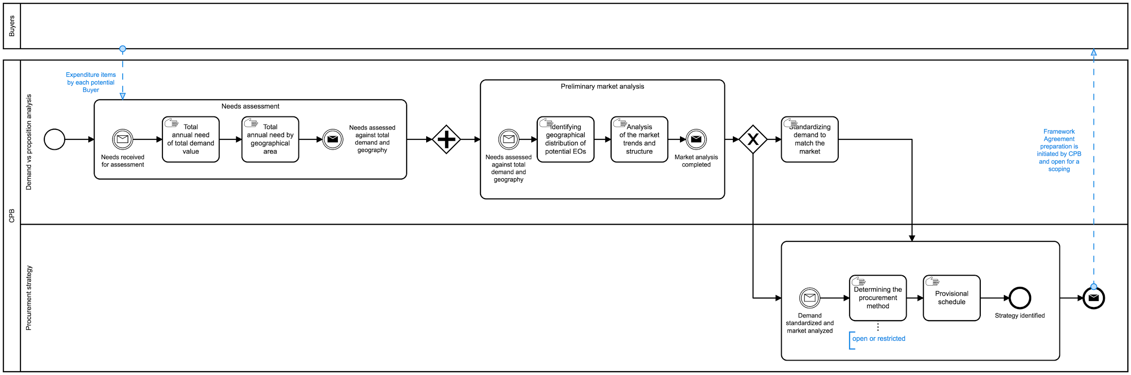

*BPMN for a process of initiation of a framework agreement (*[*interactive version*](https://cawemo.com/share/23f00821-b867-413d-b62c-eb482f34a1d6)*)*

## Common flow of an aggregated planning

A principle business-process of an aggregation of a Buyers indicative notices looks like following:

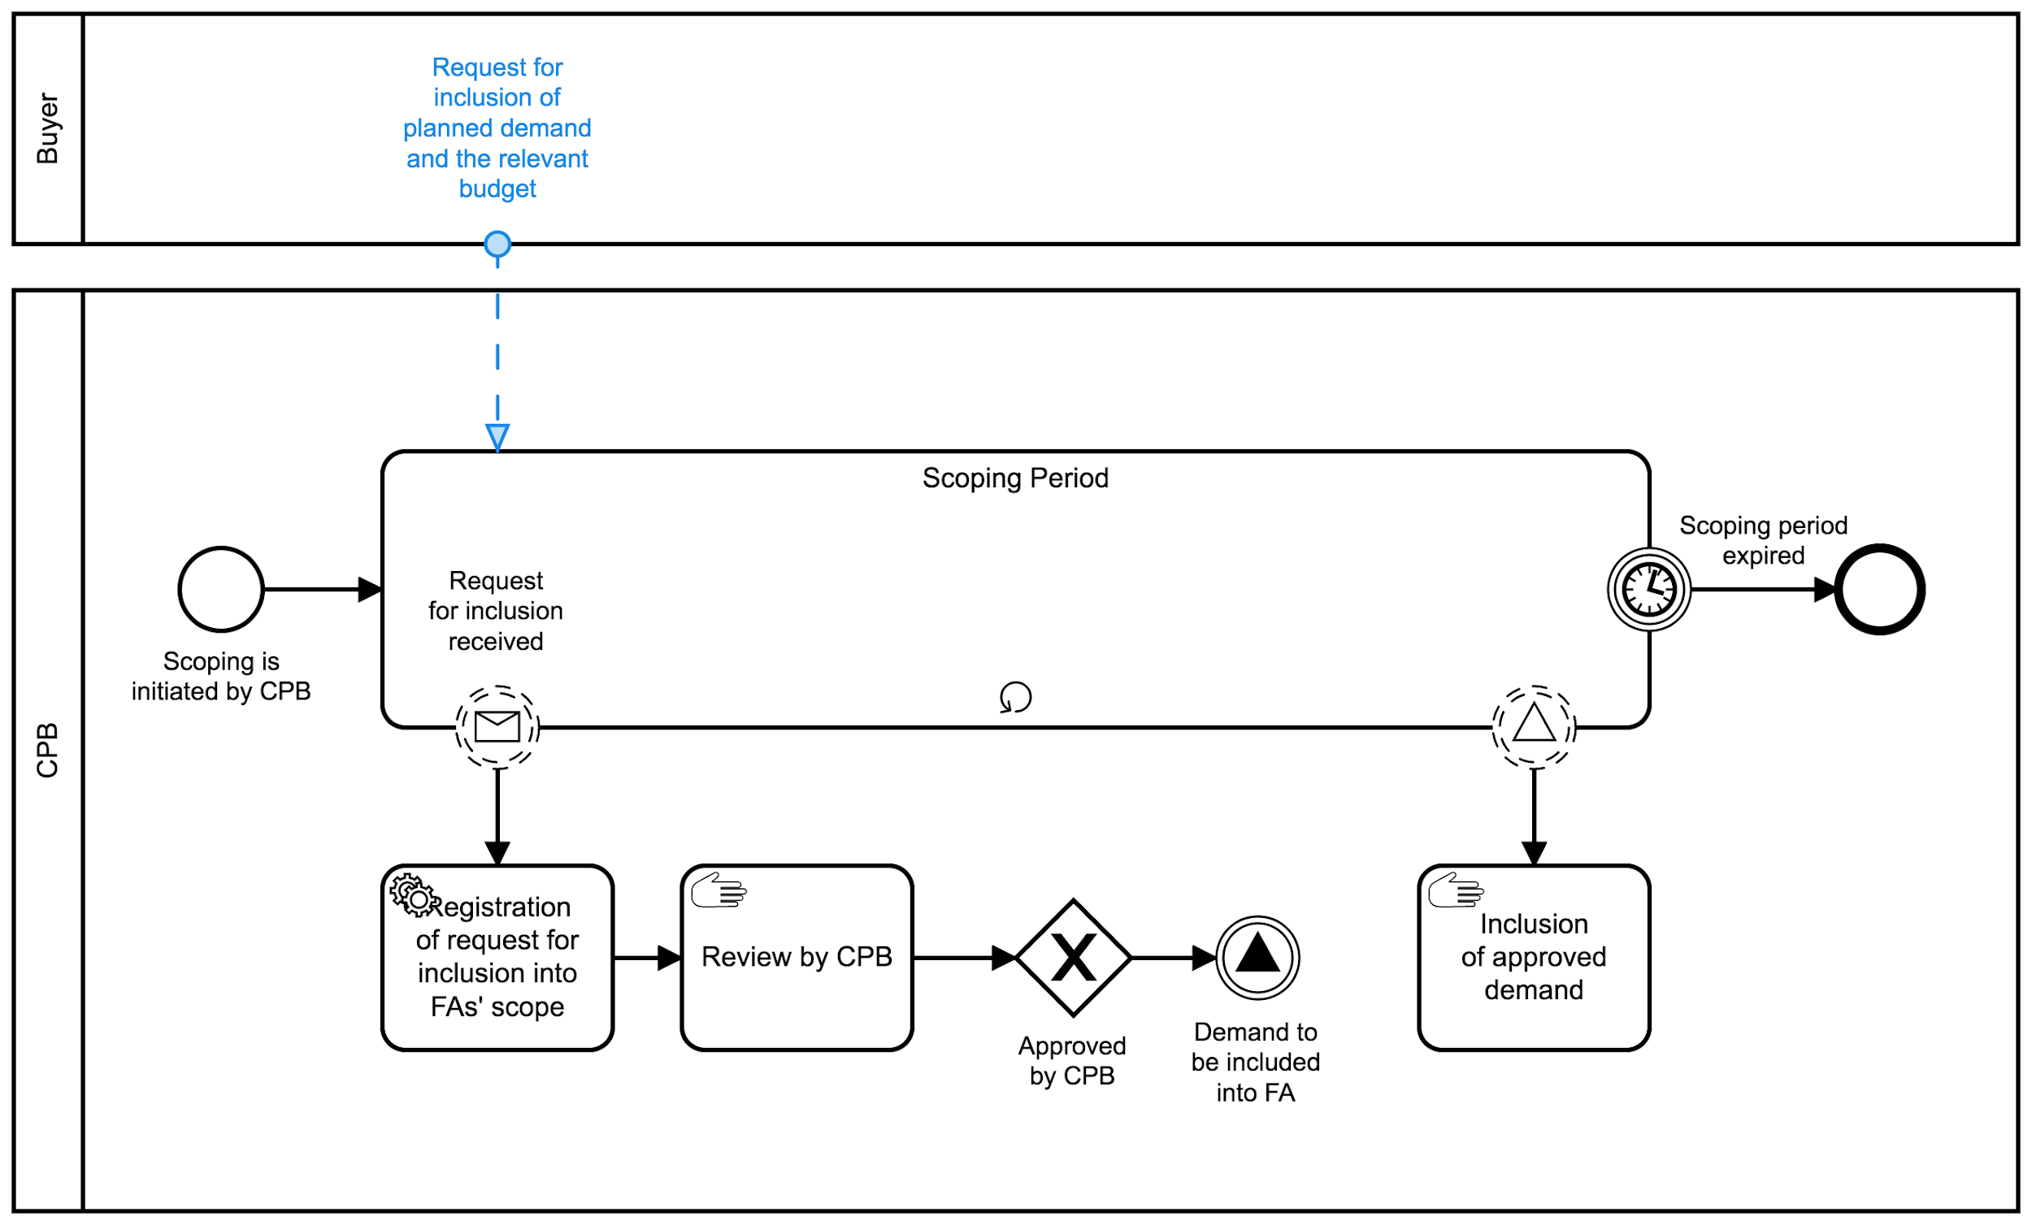

*BPMN for common online selective procedure for utilities (*[*interactive version*](https://cawemo.com/share/1ae8009c-d717-4ad0-aabc-f4b87337b925)*)*

## Common flow of a design of a framework agreement

The high-level of a design of a framework agreement expressed in a following diagram:

## 

## Common process of a framework agreement establishment

The Profile covers a common flow of procurement procedure for utilities based on a selective method:

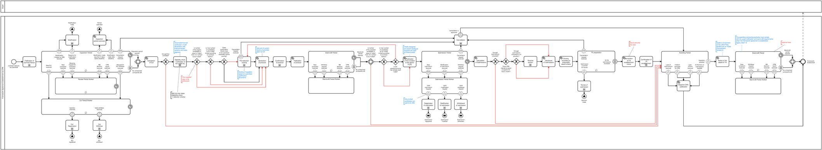

*BPMN for common process of a framework agreement establishment (*[*interactive version*](https://cawemo.com/diagrams/aa5f54c2-26da-4129-a698-e1da462b1a45--frameworkagreement-establishment-by-cpb?v=-5975,-2107,0.407)*)*

# 

# Technical design

In order to implement a Profile in a MTender system the following technical design is applied:

## Preparation of framework agreement establishment

As it is stated above, contracting process for an establishment of a framework agreement based on an online selective procurement method and begins from a cameral demand analysis (based on detailed expenditure items of the Buyers) and aggregated planning as a multi-relation with a number of periodic indicative notices by the Buyers who intend to become a party of further framework agreement by CPB. Thus, an establishment of a framework agreement on a technical layer begins from an initiation of a relevant contracting process and publication of a draft of a future aggregated plan where all the relations with the periodic notices aggregated by CPB as a common scope of a framework agreement to be established.

### Initiation of a contracting process for a framework agreement

Initiation of a contracting process in case of framework agreement goes in the same way as for any other procurement methods - with a publication of a planning notice (PN) which in this case is a draft of a future aggregated plan (AP). Thus, the relevant request for initiation of a contracting process based on [createPN.ap](http://some) command-model to be sent to a BPE:

|  |
| --- |
| /do/ap?country=...&pmd=... |

**Request parameters**

|  |  |  |  |
| --- | --- | --- | --- |
| country | Identifier of country of jurisdiction according to *country* codelist | | |
| pmd | Identifier procurementMethodDetails according to *pmd* codelist | | |

As a result, a new contracting process for a farther framework agreement (FA) with a relevant attributes will be initiated in the system as well as draft of a future aggregated plan (AP).

### Collection of demand and aggregated planning

The Aggregated Plan (AP) contains information about multiple individual procurement plans. Through the aggregation of demand CPBs could significantly diminish costs of procedures. Procurement techniques that involve aggregation usually take longer to award than non-aggregated procurement processes, but they are associated with lower cost than running "standard“ restricted or negotiated procedures. CPBs are more professional and aggregation may permit greater strategic buying power Repetitive purchasing and issues of aggregation are inevitably evoked in the context of CPBs since the reason to establish them is usually to provide smaller contracting authorities with the benefits of economies of scale.

On a data-level, *aggregation* means setting up a relationship between different data-sets and inheritance of specific data in order to reflect aggregation and its scope.

The logic illustrated with the following component diagram consist of a sequence of relations set based on the business process performed.

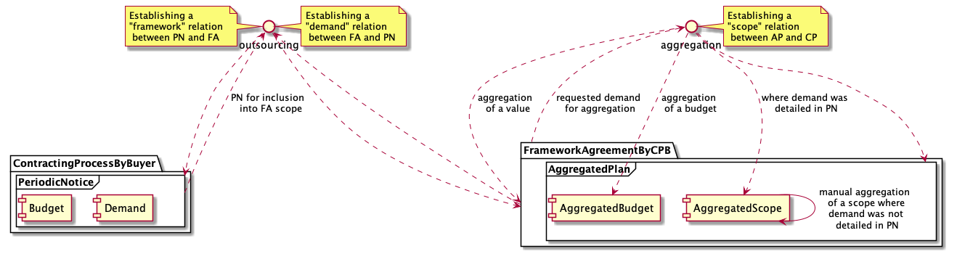

*Component diagram of a collection and aggregation of a periodic notices as a aggregated plan*

#### Collection of a needs to be included into a aggregated plan

According to a business process above, once a potential Buyer becomes aware of CPBs intention to establish a framework agreement for a specific category of goods or services, he can request from CPB an inclusion of his relevant demand and related budget into a scope of such FA. To do so, Buyer needs to describe his demand first by initiating a separate contracting process against previously declared annual needs (expenditure item classified with a certain CPV code) and publication of a relevant periodic notice, describes provisional schedule, budget allocated and, at least common definition of a subject of procurement. Once such data is ready on Buyers' side, the inclusion of a demand can be requested from CPB through establishing a relation between periodic notice of contracting process and the framework agreement. Such a relation serves as a data-hook of inclusion requests recorded.

|  |
| --- |
| /do/outsourcing/cpid/ocid?FA=...&AP=... |

**Request parameters**

|  |  |  |  |
| --- | --- | --- | --- |
| cpid | Identifier of a contracting process whichs PN is to be requested for inclusion into aggregated plan | | |
| ocid | Identifier of a PN which is to be requested for inclusion into aggregated plan | | |
| FA | Identifier of a FA where a received PN is to be included as a request for aggregation | | |
| AP | Identifier of a aggregated plan under targeted framework agreement | | |

As a result, a relevant relation will be established in FA to PN received as follows:

|  |
| --- |
| {  "relatedProcesses": [  {  "id": "",  "relationship": [  "x_demand"  ],  "identifier": ""  }  ] } |

And the reverse relation in PN to FA as follows:

|  |
| --- |
| {  "relatedProcesses": [  {  "id": "",  "relationship": [  "framework"  ],  "identifier": ""  }  ] } |

Thus, all the requests by the Buyers interested in their needs to be covered by further framework agreement will be collected in an AP drafted by CPB as the related processes with a relevant relationship: x_demand.

#### Aggregation of requested demands

On a CPB side, each requested inclusion to be reviewed by CPB and decided on whether this request is a subject of this framework from classification, geography, volume and etc perspectives. If compliant and CPB decides to include this demand into a scope of future framework agreement, such demand is to be aggregated through establishing a relevant relation:

|  |
| --- |
| /do/relation/cpid/ocid?CP=...&PN=... |

**Request parameters**

|  |  |  |  |
| --- | --- | --- | --- |
| cpid | Identifier of a contracting process whichs PN is to be requested for inclusion into aggregated plan | | |
| ocid | Identifier of a PN which is to be requested for inclusion into aggregated plan | | |
| FA | Identifier of a FA where a received PN is to be included as a request for aggregation | | |
| AP | Identifier of a aggregated plan under targeted framework agreement | | |

As a result, a relevant relation will be established in AP to PN received as follows:

|  |
| --- |
| {  "relatedProcesses": [  {  "id": "",  "relationship": [  "x_scope"  ],  "identifier": ""  }  ] } |

In the same way CPB proceeds with all the requests collected during a certain determined period of time and, having the final aggregated scope, CPB can complete a scoping period and start with a design of framework, preparation of a pre-qualification phase and a framework establishment itself.

#### Description of a scope of an aggregated plan

Since aggregation of a subject of procurement from multiple sources (periodic notices by Buyers) into single common scope (AP) doesn't seem a linear process and often requires a human-analysis, at this stage a subject aggregation together with a “lots” strategy goes to CPB as a manual process.

In order to reflect a summary of an aggregation - subject of matter of this contracting process as a set of items and lots, CPB supposes to update AP with a relevant substance. To do this, relevant request for an update of a AP based on [updatePN.ap](http://some) command-model to be sent to a BPE:

|  |
| --- |
| /do/ap/cpid/ocid |

**Request parameters**

|  |  |  |  |
| --- | --- | --- | --- |
| cpid | Identifier of a FA where a received PN is to be included as a request for aggregation | | |
| ocid | Identifier of a aggregated plan under targeted framework agreement | | |

In the same way CPB proceeds with all the updates up to all the demand collected via the aggregated plan is reflected in its scope. Once done, CPB can start with collection of expressions of interest from a market.

##### Determining product categories and products

The subject matter of framework agreements is works/goods/services. However, as framework agreements are established for repeating needs and usually include a form of aggregated purchasing, challenges regarding the subject matter often occur. The issues relate to the uncertainties of how detailed the subject matter must be identified and described, and question whether substitution of subject is allowed, and if yes, to what extent. These uncertainties are particularly important within framework contracts, where all terms and conditions for awarding call-offs are established at the stage of concluding a framework - framework establishment. As a scope for change is limited in comparison with framework agreements, where a mini-competition or further specification of terms will be applicable.

Technically, determining of a product categories is a determination of a relevant list of items with aggregated classification according to CPV and decomposed place of performance (delivery).

Simplest case when the only category of goods scoped for relatively same (or even same) geography:

|  |
| --- |
| {  "tender": {  "items": [  {  "id": "001",  "description": "Notebooks",  "quantity": 200,  "classification": {  "schema": "CPV",  "id": "30213100-6",  "description": "Portable computers"  }  },  "deliveryAddress": {  "region": "Florida"  }  ]  } } |

More complex case when a common volume in a category of goods is divided through geography:

|  |
| --- |
| {  "tender": {  "items": [  {  "id": "001",  "description": "Notebooks",  "quantity": 150,  "classification": {  "schema": "CPV",  "id": "30213100-6",  "description": "Portable computers"  }  },  "deliveryAddress": {  "region": "Florida"  },  {  "id": "002",  "description": "Notebooks",  "quantity": 50,  "classification": {  "schema": "CPV",  "id": "30213100-6",  "description": "Portable computers"  }  },  "deliveryAddress": {  "region": "California"  }  ]  } } |

##### Determining the legal type of FA

###### Fixed and non-fixed terms

When it comes to framework agreements that do not include all terms and conditions, it is required that these are further specified and substituted when necessary at the stage of awarding call-offs.

###### Indication whether options are used and other information about options

A buyer may have a right – but not an obligation – to additional purchases from a supplier while the contract is valid. For example, a contract may concern a thousand uniforms, and the buyer may have the option to request an additional hundred uniforms. This may be useful if, when initiating the contracting process, the buyer doesn't yet know whether a planned increase in staff will take place.

The options.hasOptions field can be set to true, and the options.description field can describe the options for additional purchases. hasOptions and options.description can also be set on lot objects in the tender.lots array:

|  |
| --- |
| {  "tender": {  "lots": [  {  "id": "001",  "options": {  "hasOptions": true,  "description": "The buyer has the option to buy an additional hundred uniforms."  }  }  ]  } } |

###### Information on the recurrence of the contracting process

Such information needed if, for example, another procurement procedure or qualification system for the same contract matter is likely to be re-launched, or re-established, in the foreseeable future. Note that this does not mean awarding multiple contracts within a single qualification system, framework agreement, or dynamic purchasing system; in these cases, these fields should not be used. This information can be useful, for example, to companies deciding whether to invest into machinery necessary for a particular contract. With this information, they know that there will likely be an opportunity to win similar contracts in future years, which may make the investment more worthwhile.

|  |
| --- |
| {  "tender": {  "lots": [  {  "id": "001",  "recurrence": {  "hasRecurrence": true,  "dates": [  { "startDate": "2020-01-01T00:00:00Z" },  { "startDate": "2021-01-01T00:00:00Z" }  ],  "description": "The duration of this contract and recurrent contracts less then 3 y"  }  }  ]  } } |

###### Description of the options for the renewal of contracts

|  |
| --- |
| {  "tender": {  "lots": [  {  "id": "001",  "renewals": {  "hasRenewals": true,  "variantsDetails": "Contracts are due to be renewed one time at the end of term"  }  }  ]  } } |

###### Information about variants

|  |
| --- |
| {  "tender": {  "lots": [  {  "id": "001",  "variants": {  "hasVariants": true,  "variantsDetails": "Any relevant items are permitted"  }  }  ]  } } |

##### Duration of a future framework agreement by each defined category

The duration of a framework agreement may generally not exceed four years and may be shorter.

|  |
| --- |
| {  "tender": {  "contractPeriod": {  "durationInMonth": 36,  "startDate": "",  "endDate": ""  }  } } |

## Call for expressions of interest

Preparation of Call for expressions of interest under a contracting process based on an online selective procurement method is made by preparation and publication of a contract notice based on a prior notice. In case of framework agreement such prior notice is an AP. To introduce a new Contract Notice as a call for expressions of interest for procedure based on a selective method [createCNonPN.selective](http://some)-online command-model should be used for preparation of POST-request for BPE:

|  |
| --- |
| /do/fe/cpid/ocid |

**Request parameters**

|  |  |  |  |
| --- | --- | --- | --- |
| cpid | Identifier of a framework agreement where a call for EoI is to be published | | |
| ocid | Identifier of a aggregated plan under targeted framework agreement | | |

As a result of the command execution a separate ocds-record based on [cpPhase.FE](http://some) is formed in the system describing the Contract Notice created.

### Specific information

Together with all the common information applicable for any of contract notices for other procurement methods, the following additional information is specifically applied in case of an announce of establishment of a framework agreement:

#### Applied techniques

##### Pre-qualification

Separate preQualification block shall be included into Contract Notice in order to initiate a call for EoI:

|  |
| --- |
| {  "preQualification": { } } |

##### Second-stage parameters

A separate technique according to PAPI-11-8: Second-stage: PE allowed to limit a number of candidates to be invited to submit financial offers later on. Where this is a case, pre-selection instead of pre-qualification will be applied in order to evaluate candidates. To limit number of candidates, secondStage building block to be included inside:

|  |
| --- |
| {  "tender": {  "secondStage": {  "minimumCandidates": 2,  "maximumCandidates": 5  }  } } |

##### Other criteria

A separate technique according to PAPI-11-3: Other criteria - reduction of the number of candidates according to a limits by secondStage:

|  |
| --- |
| {  "tender": {  "otherCriteria": {  "qualificationSystemMethods": [""], *// The value from enum ["automated" or "manual" ]*    "reductionCriteria": "" *// The value from enum ["scoring" or "none" ]*  }  } } |

##### Award criteria

Set of criteria may include different types of requirements based on [PAPI-11-2: Qualification criteria](https://docs.google.com/document/d/1obBk8_6qmt58t42ZMifbEeHuJYp1Pd-Ht87KPir99WU/edit#heading=h.ha0zurdml4c4), used in different ways and for different reasons.

##### Conversions

Where scoring function to be applied, a set of verifiable conversions needed for future ranking and evaluation as described in a PAPI-11-5: Scoring function and conversions

##### Requirement of an electronic catalogue to be submitted

If all the further financial offers to be expressed with a pre-award catalogue

|  |
| --- |
| {  "tender": {  "requiresElectronicCatalogue": *// true/false boolean value*  } } |

#### Evaluation panel

A set of Procuring Entities’ evaluation panel could be announced based on PAPI-11-7: Evaluation panel

### State-chart diagram

The life cycle of a cpPhase.FE for an establishment of a framework agreement based on selective method consists of the following states:

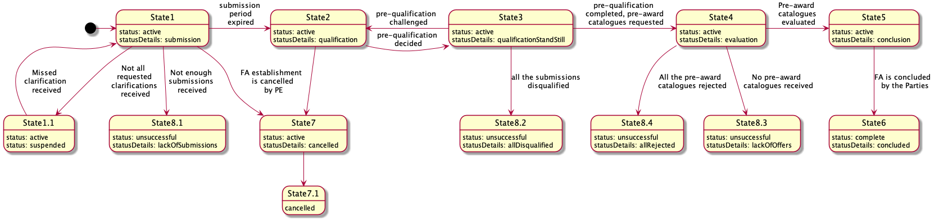

*State-chart diagram for an establishment of a framework agreement based on selective method*

## Submission of expressions of interest by interested EOs

Along with publication of a contract notice for a framework establishment, the pre-qualification phase shall be launched in order to indicate a time-frame for submission of expressions of interest based on either PAPI-4-1: Submission - expression of interest or PAPI-4-2: Advanced submission - expression of interest based on ESPD dependign on PEs’ strategy. Separate preQualification block of a query-model expresses such time-frame:

|  |
| --- |
| {  "preQualification": {  "period": {}  } } |

Submission of EoIs is available for any interested economic operator during a certain period determined by tender documents. Each EoI shall fulfill all the requirements prescribed by the qualification criteria related to tenderers with a relevant list of the responses by EO. To send a submission for procedure based on a selective method a [createSubmission](http://some) command-model should be used for preparation of POST-request for BPE with an indication of the following parameters:

|  |
| --- |
| /do/submission/cpid/ocid |

**Request parameters**

|  |  |  |  |
| --- | --- | --- | --- |
| cpid | Identifier of a framework agreement where a EoI is to be submitted | | |
| ocid | Identifier of a framework establishment under targeted framework agreement | | |

## Enquiries - requests and clarifications

Within prescribed by a contract notice enquiryPeriod any interested EO allowed to send a request for clarification according to PAPI-12-1: Clarification of conditions.

## Pre-qualification by CPB

### Initiation of pre-qualification

#### Disclosure of submissions

Where enough submissions is a case, all the submissions to be disclosed as submissions array according to the relevant schema:

|  |
| --- |
| {  "submissions": { } } |

#### Establishment of a period for qualification by PE

In order to indicate a start of the qualification phase of a contracting process a separate qualificationPeriod.startDate will be added into a preQualification:

|  |
| --- |
| {  "preQualification": {  "qualificationPeriod": {  "startDate": ""  }  } } |

#### Qualification envelopes

Along with initiation of a prequalification by CA, a set of qualifications to be established against each submission received in order to allow CA to reflect its decision against each such submission.

|  |
| --- |
| {  "qualifications": [  {  "id": "",  "status": "pending",  "statusDetails": "awaiting",  "candidates": [],  "relatedSubmission": ""  }  ] } |

Such objects are initially established with status:pending and statusDetails:awaiting. Since no order is prescribed for the prequalification sequence - CA can qualify submissions received randomly.

### Initial ranking of submissions according to qualification criteria

Depending on tender.awardCriteria and tenderAwardCriteriaDetails initial automated ranking can or can not be done automatically according to PAPI-5-3: Initial ranking - simple pre-selection, PAPI-5-4: Scoring - advanced pre-selection or PAPI-5-2: Automated pass/fail - advanced qualification.

### Declaration of non-conflict of interest

Before starting qualification, each declared member of the evaluation panel (see PAPI-11-6: Evaluation panel) shall respond against each candidate from each submission received according to a common flow prescribed by a Profile PAPI-8-1: Declaration of absence of conflict of interest by CA.

### Qualification of a submissions

Once all the declarations of non-conflict of interest against specific candidates are submitted by evaluation committee, related qualification may be switched into statusDetails: consideration

|  |
| --- |
| /do/consideration/qualification/cpid/ocid/qualificationId |

**Request parameters**

|  |  |  |  |
| --- | --- | --- | --- |
| cpid | Identifier of a framework agreement where qualification is taking place | | |
| ocid | Identifier of a framework establishment under targeted framework agreement | | |
| qualificationId | Identifier of a qualification to be updated | | |

#### Consideration

In order to evaluate a submission against qualification criteria and reflect CPBs’ decision on considered submission one of the following profiles shall be applied (depending on procurement strategy under specific procurement process): PAPI-5-1: Pass/fail - simple qualification or PAPI-5-5: Distributed qualification - conditions-driven decision making

CPB shall update qualification with all the required meta-data. Under such updates PE allowed to:

* add any qualification.documents if needed
* add text qualification.description where any justification is needed
* add qualification.internalID if any

#### Indication of a decision

Once consideration of specific submission is completed and related qualification is fully updated with all the relevant data, CPB shall switch such a qualification in a one of the states, reflecting positive or negative decision in its regard:

* qualification.statusDetails: active - means related submission is qualified
* qualification.statusDetails: unsuccessful - means related submission is disqualified

In order to implement both consideration and indication of a decision, a targeted qualification shall be updated according with an [updateQualification](http://some) command-model with a following request to a BPE:

|  |
| --- |
| /do/qualification/cpid/ocid/qualificationId |

**Request parameters**

|  |  |  |  |
| --- | --- | --- | --- |
| cpid | Identifier of a framework agreement where qualification is taking place | | |
| ocid | Identifier of a framework establishment under targeted framework agreement | | |
| qualificationId | Identifier of a qualification to be updated | | |

### Qualification protocol

As soon as CA has completed qualification and all the qualifications are updated with relevant meta-data and statuses details, CA indicates the end of pre-qualification by submitting a protocol:

|  |
| --- |
| /do/protocol/qualification/cpid/ocid |

**Request parameters**

|  |  |  |  |
| --- | --- | --- | --- |
| cpid | Identifier of a framework agreement where qualification is taking place | | |
| ocid | Identifier of a framework establishment under targeted framework agreement | | |

### Withdraw qualification protocol

If there are some blockers raised up during stand-still period (out of system), CPB can withdraw a previously submitted qualification protocol and step back to a qualification in order to address blockers:

|  |
| --- |
| /cancel/protocol/cpid/ocid |

**Request parameters**

|  |  |  |  |
| --- | --- | --- | --- |
| cpid | Identifier of a framework agreement where qualification is taking place | | |
| ocid | Identifier of a framework establishment under targeted framework agreement | | |

### Completion of qualification

If no blockers indicated during stand-still period (out of system), CPB can initiate the end of qualification:

|  |
| --- |
| /confirm/qualification/cpid/ocid |

**Request parameters**

|  |  |  |  |
| --- | --- | --- | --- |
| cpid | Identifier of a framework agreement where qualification is taking place | | |
| ocid | Identifier of a framework establishment under targeted framework agreement | | |

Such completion of a qualification period will cause a also following consequences:

#### Completion of qualification period

Additional value will be added into preQualification.qualificationPeriod as an indication of a completion of qualificationPeriod

|  |
| --- |
| {  "preQualification": {  "qualificationPeriod": {  "endDate": ""  }  } } |

#### Finalization of pre-qualification

All the qualifications shall be moved into relevant final statuses:

* qualification.status: pending / statusDetails: active → qualification.status: active / statusDetails: none - means related submission is qualified and a candidate(s) is invited to submit a commercial offer
* qualification.status: pending / statusDetails: unsuccessful → qualification.status: unsuccessful / statusDetails: none - means related submission is disqualified)

And all the related submissions to relevant statuses:

* where related qualification.status: active → submission.status: valid
* where related qualification.status: unsuccessful → submission.status: disqualified

#### Completion of pre-qualification

Character of a result of the pre-qualification to be reflected with:

* preQualification.status.complete where enough number of candidates were selected for future invitation to submit an offer
* preQualification.status.unsuccessful where pre-qualification completed in a negative way due to lack of submissions or because all the submissions were disqualified

## Pre-award catalogue request

Once pre-qualification and a following stand-still period are over, a sourcing phase shall be initiated by CPB by a publication of a number of pre-award catalogue requests according to a design of a framework agreement and a distinction of a subject matter.

In order to initiate a collection of indicative offers and competition on it by all the qualified suppliers, CPB shall publish a separate pre-award catalogue request for each separate part of a subject matter.

To start a new Pre-award catalogue request, a [createPCRonFE](http://some) command-model to be used for preparation of POST-request for BPE with an indication of the following parameters:

|  |
| --- |
| /do/pcr/cpid/ocid |

**Request parameters**

|  |  |  |  |
| --- | --- | --- | --- |
| cpid | Identifier of a framework agreement where PCR is needed | | |
| ocid | Identifier of a framework establishment under targeted framework agreement | | |

### Specific information

Together with all the common information applicable for any of contract notices for other procurement methods, the following additional information is specifically applied in case of an announcement of pre-award catalogue request:

#### Measurable targets

Set of sepcific targets describes an expected verifiable measures and values to be achieved within this pre-award catalogue request can be included according to PAPI-11-1: Targets and metrics.

#### Applied techniques

##### Electronic auction

An eAuction can be included as a part of process according to a Profile PAPI-11-5: Electronic auctions.

##### Award criteria

Set of criteria may include different types of requirements based on [PAPI-11-2: Qualification criteria](https://docs.google.com/document/d/1obBk8_6qmt58t42ZMifbEeHuJYp1Pd-Ht87KPir99WU/edit#heading=h.ha0zurdml4c4), used in different ways and for different reasons.

##### Conversions

Where scoring function to be applied, a set of verifiable conversions needed for future ranking and evaluation as described in a PAPI-11-5: Scoring function and conversions.

## Submission of pre-award catalogues by qualified candidates

According to PAPI-6-1: Bid - simple tendering or PAPI-6-2: Structured Bid - advanced tendering each invited candidate allowed to submit his bid within the given tender.tenderPeriod. Each bid shall fulfill all the requirements prescribed by the criteria related to item or lot with a relevant list of the responses by EO by providing an array of requirementResponses.

Thus, each offer includes:

* a reference on organization profile sent previously while submitting an expression of interest, in case of two-stage procedures)
* set of documents of the offer, specified with relevant types of documents for their future splitting into the different "envelopes"
* absolute financial value of an offer
* set of required responses according to criteria specified by Contract Notice related to financial part of the offer:
  + reflections on requirements characterise the nature of the subject of procurement
  + reflections on requirements characterise the nature of the delivery and post-delivery

Such requests based on bid schema:

|  |
| --- |
| {  "bid": {  "id": "",  "status": "",  "relatedLots": [],  "tenderers": [],  "items": [  {  "id": "",  "description": "",  "quantity": ""  }  ],  "requirementResponses": []  } } |

All the proposals collected remain confidential and closed until expiration of a period for tendering - tender.tenderPeriod.endDate. Once tender.tenderPeriod.endDate achieved, no offers to be received, withdrawn or corrected.

## Electronic auction

An eAuction can be included as a part of process according to a Profile PAPI-11-5: Electronic auctions

## Evaluation by CPB

### Initiation of an evaluation

#### Disclosure of the pre-award catalogues

Where enough offers is a case, all such offers to be disclosed as an bids array according to the relevant schema.

|  |
| --- |
| {  "bids": {  "details": [] } |

#### Establishment of a period for evaluation

Separate object awardPeriod to be added into a tender where the certain start date for awarding is determined automatically.

|  |
| --- |
| {  "tender": {  "awardPeriod": {  "startDate": ""  }  } } |

#### Evaluation envelopes

Along with establishment of tender.awardPeriod.startDate a set of awards to be established against each bid received in order to allow CA to reflect its decision against each such bid. Such objects are based on award schema and initially established with status:pending for all.

|  |
| --- |
| {  "awards": [  {  "id": "",  "status": "pending",  "suppliers": [],  "relatedLots": [],  "relatedBid": ""  }  ] } |

### Initial ranking on evaluation criteria

Depending on tender.awardCriteria and tenderAwardCriteriaDetails initial automated ranking can or can not be done automatically according to a Profile PAPI-7-2: Initial ranking for evaluation

### Evaluation by contracting authority

Once an initial ranking according to applied awarding methodology is done, CA can start with a manual evaluation according to either PAPI-7-1: Simple manual evaluation or PAPI-7-3: Scoring function - advanced evaluation

### Conclusion of a post-award catalogue

The evaluation process ends by submission of a protocol that reflects the entire results of tendering. Once evaluation is completed and each considered offer is indicated with a relevant state, CA submits the evaluation protocol which, in its turn, indicates the publication of the contract award notices according to Profile PAPI-9-1: Award decision - contract award notice. Such protocol has to be submitted for each lot separately.

## Conclusion of a framework agreement

## Cancellation of a procedure

See [PAPI-3-3: Termination of a procedure](http://some)

# Command models

The following command-models to be used to operate with a data-objects under offline procedure based on a limited method

### updatePN.ap

### createPN.ap

### createCNonPN.selective-online

In order to describe and contribute a Contract Notice for a procedure based on a limited method, a following structure to be used:

|  |  |
| --- | --- |
| **Attribute** | **Description** |
|
| tender.title | Title for this part of CP |
| tender.description | Description for this part of CP |
| tender.awardCriteria | Specify the award criteria for the procurement |
| tender.awardCriteriaDetails | Specify the award criteria details for the procurement |
| tender.lots | A tender process is divided into lots |
| tender.items | The goods and services to be purchased |
| tender.submissionMethod | Specify the method by which bids must be submitted |
| tender.submissionMethodRationale | A value that identifies the rationale where electronic submission method is not to be allowed |
| tender.submissionMethodDetails | Any detailed or further information on the submission method. |
| tender.documents | All documents and attachments related to the tender, including any notices. |

### createSubmission

### updateQualification

### createPCRonFE